C:\Users\User\Mahoney Legal Dropbox\campaign_general (1)\.0001 The Economy Movement\.0001 The Economy Movement\000000,NeighborhoodStuff\More new comments.docx

Greg BakerRidgetop • 1 day ago
Texas government knew they weren't ready 10 years ago... and did nothing. 10 years ago, Texas had blackouts during a winter storm in February. "Texas experienced an arctic cold front that brought unusually cold temperatures and gusty winds to the entire state for two days. Due to an unfortunate combination of weather-related factors... ERCOT lost roughly one-third of its generation fleet... natural gas production dropped due to freeze-offs..." (p. 29) https://www.puc.texas.gov/industry/electric/reports/energy_assurance/Energy_Assurance_Plan-Texas.pdf Sound familiar? The outcome of that event created Senate Bill 1133, and amended Subchapter A, Chapter 186, Section 186.007 of the Utilities Code to give the Public Utilities Commission (PUC) the authority to: 1. analyze emergency operations plans, 2. review the emergency operations plans, 3. consider the anticipated weather patterns, 4. make recommendations, and (...wait for it...) 5. submit a report. https://capitol.texas.gov/BillLookup/Text.aspx?LegSess=82R&Bill=SB1133 The PUC mission is to “protect customers, foster competition, and promote high quality infrastructure.” The PUC also held tabletop exercises and workshops in the aftermath! 25 pages of recommendations (not specific to Texas) from 2011 (starting p. 195) are an interesting read. https://www.ferc.gov/sites/default/files/2020-04/08-16-11-report.pdf I've learned more than I've ever wanted to know about power generation and cold weather preparations from the FERC report. Good reading on a cold, cold day. TLDR; This happened before. It could have been avoided. Elect officials that serve you, not industry. Hold them accountable.

puc.texas.gov

Posted in General to Anyone
77 Neighbors
51 Comments

Like
Comment
Share

Jennifer Barnett
•
Hancock
Wow. This is a lot. Why can't they learn from their mistakes? I can't believe Austin doesn't even have the equivalent of small town snow services. Where are the snowplows and salt and sand trucks? It's really pathetic how they allow things be this crippled.
1 day ago
Like
Reply
Share
4
Cassandra Taylor
•
Hyde Park North
Yes the national guard could have been plowing roads etc.
9 hr ago
Like
Reply
Share
1

See 7 more replies
Kathleen Ensey
•
Cherrywood
Appreciate the historical perspective Greg. Having lived in D.C. and covered FERC for a while, I never thought I’d ever read a reference to FERC in Texas 😏
19 hr ago
Like
Reply
Share
4
Kathleen Ensey
•
Cherrywood
Houston resident and editorial cartoonist Nick Anderson
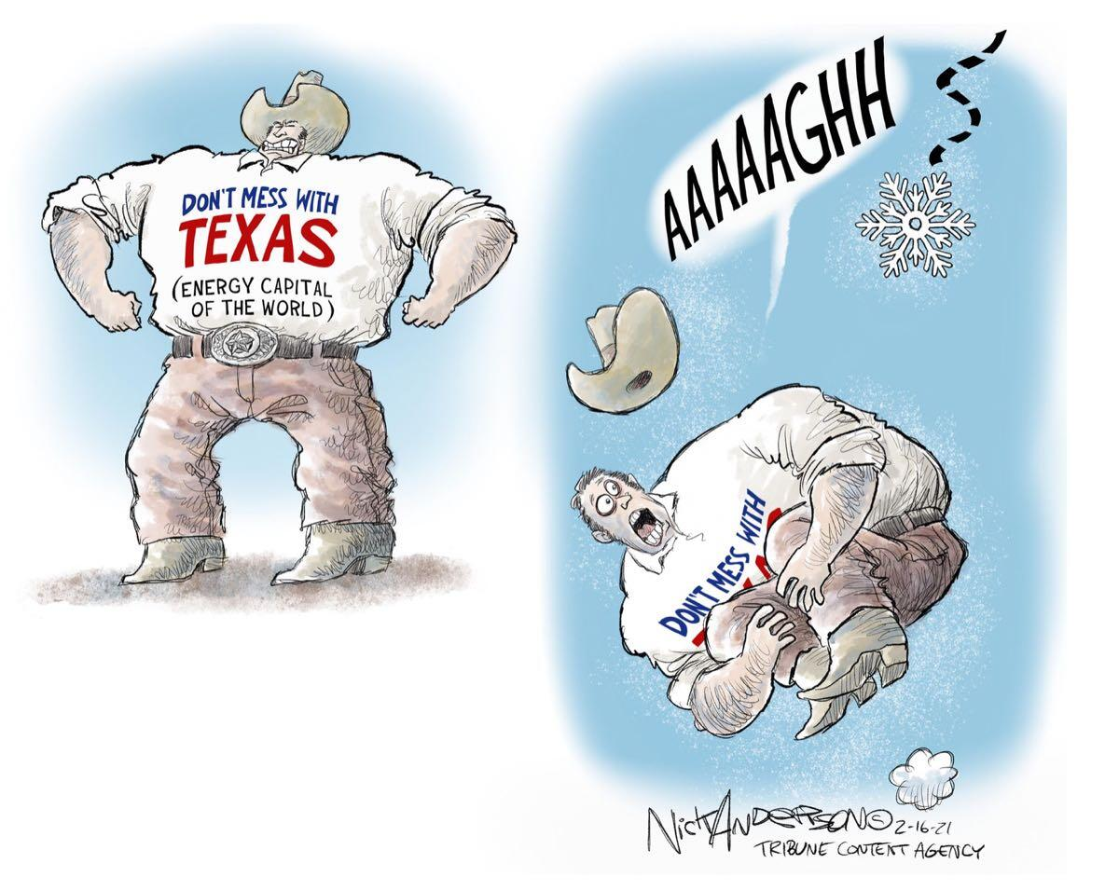
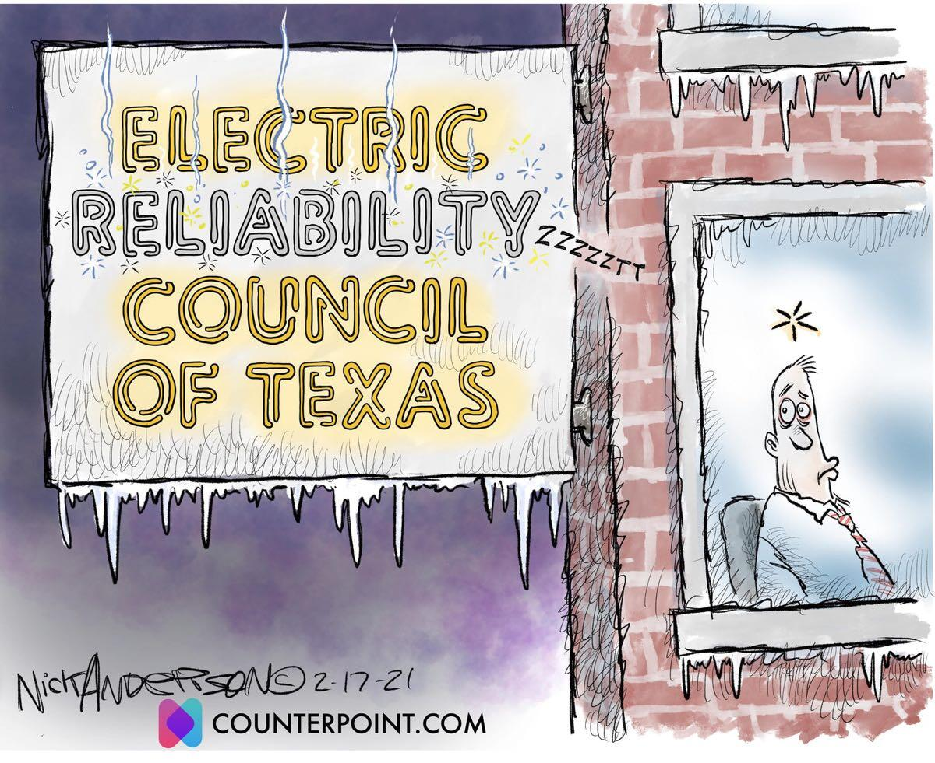

• • 8 hr ago
Like
Reply
Share
9

See 1 more reply
Lindsey Jones
•
Ridgetop
Don’t disagree with you at all, but let’s focus on that part once we’re through this. For now, let’s focus on taking care of ourselves and our neighbors. Plenty of time to rain hell later. Ya know?
18 hr ago
Like
Reply
Share
4
Tim Mahoney
•
Ridgetop
In my neighborhood block, we're done on-going outreach to make sure that people who have had to go to other places (like motels) to protect their children and pets have their homes as best protected as is possible. In addition, we have also been monitoring individuals, including the elderly, who do not have the option of going to other places. This is beyond the Pale, and if we don't create alliances now for common cause, what is the point. Thanks Mr. Baker for your coherent research. The only real solution to this present situation is to build Trust between most of us, from one block to another. Make no mistake about this: our leaders have been willing to let many of us die in order to enhance the insanity that has hobbled Texas for at least the last 20 years, since Governor Perry started lying about many issues, including education. Hey, stay safe out there!
14 hr ago
Like
Reply
Share
9
Thomas Miner
•
Highland
Governor should have built a better power grid than a wall! What was Governor appointed PUC doing? Obviously no future planning for state and lining their pockets with our money. Energy Secretary Perry is missing.
8 hr ago
Like
Reply
Share
2
Wesley Barnett
•
Hancock
Come on man, when I lived in Dallas, all major roadways were salted and sanded...it's a matter of lack of preparation.
6 hr ago
Like
Reply
Share
2
Deanne Quarrie
•
Coronado Hills
This is freak weather - never before seen here. How do you plan for that?
5 hr ago
Like
Reply
Share
1

See 2 previous replies
Laura Brown
•
Windsor Park Southeast
Deanne, If you read the above post, it did happen before. In 2011. (And in 1989.) That’s what 1 entire report covers. https://www.ferc.gov/sites/default/files/2020-04/08-16-11-report.pdf(edited)
3h
Like
Reply
Share
3
Bobby Sledge
•
North Loop
The lack of information is tricky and our public safety professionals should do a better job of prepping us with carefully-crafted advice such as bulletins (in addition to press conferences). For example, I don't think most people realize that if the Texas grid ever "trips off", a VERY real possibility, then we'll be without electricity and likely also see gas and water problems for many many days, some say weeks. I wonder how many days of fuel are ready for the backup generators of hospitals, law enforcement, etc.. Avoiding this blackout scenario is a primary goal of ERCOT. Who, by the way, is controlled by the PUC under the Governor & Legislature. https://www.kxan.com/news/texas/ercot-controlled-outages-over-power-can-be-restored-across-texas/
2 hr ago
Like
Reply
Share
MAVERICK SHAW
•
Central East Austin
Tucker Bradley Climate Variation/Pattern I accept; but I don’t buy Climate Change, the theory is unreliable. Moreover, climate change is an event that can NOT be predicted—because a new hypothesis must be tested each time a new observation/change is made. Climate variances can be observed frozen in the history of ice. This is a more dependable science.
1 hr ago
Like
Reply
Share
3
MAVERICK SHAW
•
Central East Austin
#carolinepadon has an odd sense of humor... but I guess any brand of humor is better than none.
1 hr ago
Like
Reply
Share
2
MAVERICK SHAW
•
Central East Austin
Here—a colorful Petri dish of happy confetti. No cry.
48 min ago
Like
Reply
Share
Tucker Bradley
•
North Loop
MAVERICK SHAW There's no benefit in arguing over semantics when it's agreed science that global climate change is induced by humanity.
43 min ago
Like
Reply
Share
3
Suzanne Barth
•
Highland
Tucker Bradley right you are! 😐
29 min ago
Like
Reply
Share
MAVERICK SHAW
•
Central East Austin
Tucker Bradley this isn’t a debate on linguistics. Climate Variation/Pattern is not to be confused for Climate Change—these are 2 different explanations. Pattern is predictable, as the name suggests. Change has less continuity; ergo is less predictable.
28 min ago
Like
Reply
Share
Suzanne Barth
•
Highland
Bobby Sledge I certainly didn’t know all these things about TX “Lone Grid”😮
25 min ago
Like
Reply
Share
MAVERICK SHAW
•
Central East Austin
Tucker Bradley I’ll put it another way. Climate Variation is a tested hypothesis, accepted as theory by a majority of expert climatologist. Climate Change is a tested hypothesis but not elevated to theory status. There isn’t enough static data to support the argument—independent variables keep changing.
16 min ago
Like
Reply
Share
Add a reply...
Tim Mahoney
•
Ridgetop
Texas really hardly plans for anything that involves regular folks; it's a systematic political failure. El Paso left the State PUC monitored power grid 10 years ago (the last benchmark winter freeze was in 2011) because of the disarray of the Texas "go it alone" hierarchy, by which a relatively small group of investors control the plants that make up the power grid. El Paso had no problem with outages this past week.
4 hr ago
Like
Reply
Share
10
Suzanne Barth
•
Highland
I didn’t know about El Paso leaving the TX Grid. Wonder how prepared were El Paso folks? 😐
27 min ago
Like
Reply
Share
Greg Baker
•
Ridgetop
I respectfully disagree with "never before seen here". I started my reading at p. 169 of https://www.ferc.gov/sites/default/files/2020-04/08-16-11-report.pdf Summary: 1. The PUC staff investigated the cold weather event of 1989 and issued a report the following year that evaluated the causes of the generator outages and made recommendations. 2. The PUC staff investigated the cold weather event of 2011 and issued a report the following year that evaluated the causes of the generator outages and made recommendations. 3. The events are so similar the PUC chose to reproduce those recommendations verbatim (in conclusion, p. 176) Maybe things changed after the 2012 report, I don't know. But history tells us "Generators were not required to institute cold weather preparedness, and efforts in that regard lapsed with the passage of time." Fun Fact: While introducing the bill (SB 1133) State Senator Glenn Hegar stated: “What I don’t want, is another storm and another report someone puts on the shelf for 21 years and nobody looks at.”
4 hr ago
Like
Reply
Share
6
Kathleen Ensey
•
Cherrywood
Greg: KXAN reporter Jody Barr even provides a link to the FERC report in his story on the ERCOT Board members: https://www.kxan.com/investigations/5-ercot-board-members-dont-live-in-texas-one-from-canada/
3 hr ago
Like
Reply
Share
1
Tim Mahoney
•
Ridgetop
Texas Tribune breaks news that "Texas officials didn't heed warnings before winter storm power outages, experts say". See the story: https://www.texastribune.org/2021/02/17/texas-power-grid-failures/
4 hr ago
Like
Reply
Share
5
David Chang
•
Hyde Park North
Total dereliction of duty.
3 hr ago
Like
Reply
Share
1
Kathleen Ensey
•
Cherrywood
One more from Houston resident & editorial cartoonist Nick Anderson: https://nickanderson.substack.com/p/ercot
3 hr ago
Like
Reply
Share
Bobby Sledge
•
North Loop
Greg thanks for the good factual references. To others trying to fihure this out, I wouldn't be too quick to jump on the blame ERCOT bandwagon. In time I think we'll see ERCOT able to fully defend all of its decisions during this disaster and leading up to it, for years. The blame should go upward, to PUC, the Governor, and the State Legislature. Abbott has been trying to deflect blame to ERCOT but, in my opinion, he has already started to back off on the veracity of this blame trajectory as he sees that ERCOT is answering all questions honestly.
2 hr ago
Like
Reply
Share
3
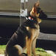
Efrain Luna
•
Colony Park/Lakeside
Where are the Karens at? We need y’all to start calling
2 hr ago
Like
Reply
Share
5
Laura Brown
•
Windsor Park Southeast
Haha Karens for a good cause!
49 min ago
Like
Reply
Share
1
Alexandria Anderson
•
Givens Park
Yes HOLD ALL Of THEM ACCOUNTABLE from the Governor down to our City Council
2 hr ago
Like
Reply
Share
1
Jan Cronk
•
Ridgetop
Since you like to read
2 hr ago
Like
Reply
Share
Ruth Fischer
•
Windsor Park Northeast
ERCOT answers to no one but their corporation, and we know how those act. Change, Resist.
2 hr ago
Like
Reply
Share
Bobby Sledge
•
North Loop
I agree corporation is a dirty word. "A corporation is an organization authorized by the state to act as a single entity" or as I've heard say "is by definition in-business with the government", and in this case has even more governmental control than most. I'll be directing my resistance energy where it matters, at the source instead of the scapegoat.
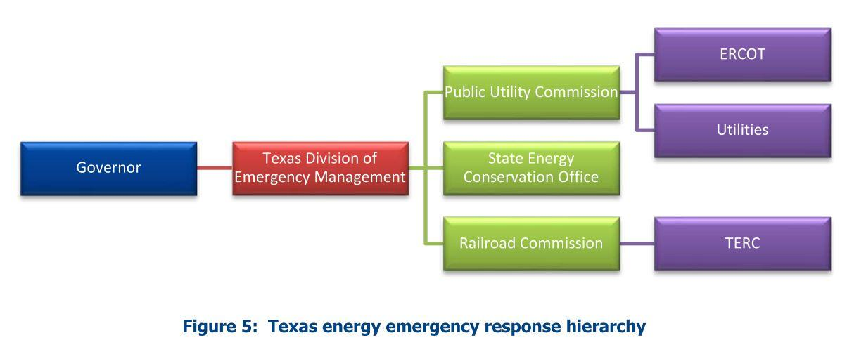
1 hr ago
Like
Reply
Share
Suzanne Barth
•
Highland
Yes this is so telling & so bad!!! 😡
1 hr ago
Like
Reply
Share
Suzanne Barth
•
Highland
I had no idea that the rest of the contiguous US States share energy thru their “mutual” grids. Only TX goes it ALONE!! 😡😡
1 hr ago
Like
Reply
Share
1
Bobby Sledge
•
North Loop
And to be clear, I'm pro-government; just not pro-THIS-Texas-government.
1 hr ago
Like
Reply
Share
2
Pam Knight
•
Rosedale
Abbot's first response was to blame the wind farms, i.e. green energy. Then ERCOT. He is the one to blame. He is in charge of the state and that includes emergency preparedness.
53 min ago
Like
Reply
Share
4
Paul Foucher
•
Hyde Park Central
If someone consistently earns more than $500,000 a year, like Ercot CEO, why would they care about doing their job well and/or helping other Texans?
46 min ago
Like
Reply
Share
Tiffany Mags
•
Mueller
I’m not sure I buy into the “they get paid too much, therefore wont do a good job” bit. Getting paid well usually corresponds to wanting to continue to do your job well. Obviously the individual leadership needs to change. Outsiders should not be on the board, period.
14 min ago
Like
Reply
Share
1
Greg Monroe
•
Crestview
There was a time when I thought the prepers were a little nutty. Maybe not so much anymore!.
44 min ago
Like
Reply
Share
1
Suzanne Barth
•
Highland
You prepare same as we do now for frequent MAJOR hurricanes. Climate is changing & mainly not for the good of humans; but it’s mainly human behavior that is changing climate 😮😐
22 min ago
Like
Reply
Share
Add a comment...

